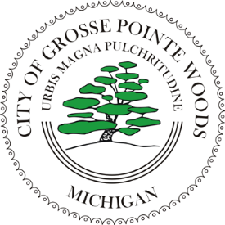

CITY OF GROSSE POINTE WOODS
(313) 343-2440
Fax (313) 343-2785
20025 Mack Plaza Drive
Grosse Pointe Woods, Michigan 48236-2397

NOTICE OF MEETING

COMMISSIONS: |  | COMMITTEES: |  | BOARDS:
Beautification Advisory |  | Building Authority |  | Board of Review
Citizens' Recreation |  | Compensation & Evaluation |  | Construction Board of Appeals
Community Tree |  | Community Events |  | Downspout Board of Appeals
Election | X | Construction |  | Pension
Historical |  | Finance
Local Officers Compensation |  | Mack Ave Business Study
Planning |  | Public Relations

Senior Citizens'

PUBLIC INVITED: IN ACCORDANCE WITH PUBLIC ACT 267 OF 1976 (OPEN MEETINGS ACT), ALL MEMBERS OF THE GROUP SELECTED ABOVE, AS WELL AS THE GENERAL PUBLIC, ARE INVITED TO ATTEND THE FOLLOWING MEETING ON Day/Date, at Time IN THE Room Name, GROSSE POINTE WOODS.

AGENDA OF MEETING
(Edit content below as necessary)

1. CALL TO ORDER
2. ROLL CALL
3. ACCEPTANCE OF AGENDA
4. ITEMS FOR DISCUSSION
5. NEW BUSINESS/PUBLIC COMMENT
6. ADJOURNMENT

cc: (Members)

File

Post

Submitted by: Office Held: Telephone:

